**Employment of ANN for Predictive Motor Maintenance and Bearing Fault Detection Using Park's Vector Analysis**

1Abishek Mahesh, 1B. Aadhi Aadhavan, 1V. Valli Meenaa, 2Madiah Binti Omar, 2Rosdiazli Bin Ibrahim, 2Nurliana Farhana Salehuddin, 3Sujatha R

1Vellore Institute of Technology, Vellore, Tamil Nadu, India

2Institute of Autonomous System, Universiti Teknologi PETRONAS, Persiaran UTP, 32610 Seri Iskandar, Perak, Malaysia

3School of Electronics Engineering, Vellore Institute of Technology, Vellore, Tamil Nadu, India

***Abstract*— Predictive maintenance is an emerging concept that is gaining mainstream popularity in industrial automation. It involves continuous monitoring of the machinery's health, status and performance in real-time. Hence, it allows the industry to schedule maintenance only when specific conditions are met and before the machinery breaks down. Critical machinery such as three-phase induction motors is being used widely in industrial processes. However, they are subjected to many electrical and mechanical stresses due to their long operating times. Bearing faults account for the highest faults in the induction motor. If the faults go unnoticed, they can result in motor failure, which generates economic losses. Thus, the tracking of motor health becomes ineluctable. One of the most effective ways to understand health and efficiency is through motor current signature analysis (MCSA). The proposed model employed MCSA by plotting Park's vector analysis graph to predict motor health. This graph would then be fed as the input to an artificial neural network (ANN) for automated classification of the healthy or unhealthy motor. The trained model has managed to acquire an accuracy >99% in the test set, thus triumphing over other predictive maintenance methods. It is designed so that the proposed model's computational complexity is low enough to run on edge computing devices to implement an efficient industrial automation system.**

**Keywords:Motor current signature analysis, Park's vector analysis, Artificial neural networks, Predictive maintenance, Industrial automation**

# **INTRODUCTION**

Induction motors (IMs) are typically used as prime movers in many industries due to their features such as low cost, ease of maintenance, high reliability, and versatility [1, 2]. However, they are highly susceptible to wear and tear and confront a plethora of unexpected failures under environmental stresses [3]. Studies show that approximately 40% to 90% of IMs failures are associated with bearing faults depending on the size of machines [3, 4]. Since bearings play a significant role in the operation of IMs, if the faults go unnoticed, they may cause catastrophic damage to the machine. Therefore, industries often undergo scheduled maintenance where the health of all these motors or bearings is checked and replaced if necessary. Instantaneous monitoring and prediction of IMs health have recently gained extensive attention among researchers. This is because early prediction will enable timely maintenance and avoid serious accidents, which may lead to economic losses and risk to the operator [2].

Numerous diagnostic methods based on diverse physical magnitudes such as vibration, temperature, current, and magnetic flux have been employed to identify the fault in the IMs [2]. Among others, motor current signature analysis (MCSA) is preferable for analyzing motor health, especially when it is in highly inaccessible or remote areas, as is common with industrial IMs. Since MCSA uses the embedded current signal of the motor's control unit, it does not require additional sensors, which results in a lower cost and complex system. The current signal can be used to remotely monitor a large number of motors from a single location. Many studies have verified the reliability of using MCSA in IMs to detect breakage in rotor bar, end ring and bearing faults [1, 5]. Park's vector approach is one of the main techniques that can be utilized for fault detection with MCSA [6-8]. This method transforms the IMs three-phase stator current into two individual orthogonal phases, and it finds the bearing fault based on the spatial variation of the Park's vector current locus. A perfect circle of Park describes healthy IMs while faults are represented with distortion on the circle.

Recognizing motor current fault signatures necessitates a high level of expertise and experience from the user. Hence, artificial intelligence (AI) has been introduced to MCSA for making detection more user-friendly besides providing automatic diagnosis and analysis of the faults in IMs. The application of artificial neural networks (ANN) is particularly suitable for performing pattern classification due to their high learning and generalization abilities [7]. Somehow, the studies related to ANN for faults detection are still limited and usually known to be heavily computation-intensive [9-12]. The present study proposed an automated system through ANN using Park's vector analysis for bearing faults detection. This method fed Park's vector graph as the input of the ANN image classifier, which would categorize the motor as healthy or unhealthy. The model is designed with low computational complexity so that the processing can be performed on the edge node.

# **LITERATURE SURVEY**

The bearing faults can be categorized according to their affected components: outer raceway defect, inner raceway defect, and ball defect [13]. Any localized faults in the component will create vibrations at the characteristic fault frequencies which can be related to the motor speed and the bearing dimensions [14]. A review in [15] indicates MCSA as the most reliable and efficient method to determine the single point faults in a bearing while being economical and non-invasive. However, this technique is unable to determine the occurrence of distributed bearing faults. Thus, many different techniques have been introduced for faults detection in IMs to overcome this drawback.

Among techniques available, Park's Vector analysis is proven able to detect localized and distributed bearing faults. An investigation of Park's vector analysis for localized faults in bearing was successfully tested a decade ago [16]. Meanwhile, its performance in detecting distributed bearing faults was first introduced in [14]. The extensive theoretical and empirical analysis provided by hardware implementation in this literature concludes that the proposed method not only diagnoses the different types of bearing faults based on the size, shape and thickness of the current patterns but also classifies them based on statistical parameters. Through Park's vector analysis, the analytical expressions to calculate any specific defect frequency are no longer required since the fault can be represented through a graphical method of the circular pattern [15].

Zarei and Yousefizadeh [17] proposed Park's vector modulus for stator current signal using wavelet packet transform. The results demonstrated that the Park vector increased the amplitude of the fault components and eliminated the main frequency of the original current measurement signal. It also showed that one could achieve fault diagnosis by comparing the energy of fault-relevant nodes for healthy and faulty signals. The uniqueness of Park's vector analysis was also observed by Sharma, Chatterji and Mathew [18], who proposed this approach for Inter-Turn Short (ITS) fault by monitoring three-phase stator current. It is claimed that the technique not only detects the presence of the fault but also estimates the level of fault severity.

Despite the fact that Park's vector approach is simple and easy to understand, it is difficult to classify multiple faults. In contrast, its extended version can easily categorize fault types but is difficult to analyze. Thus, to classify multiple faults, a new concept, Multi-layer Park's vector approach (MPVA), which combines both approaches, was proposed [19]. MPVA was also studied in [20], whereby the advantage of the proposed method is that it allows the detection and diagnosis of faults in steady and transient operating regimes in the IMs. Further, the proposed method has a comparatively lower computational cost and could thus be conducted on edge, leading to robust industrial automation. The only required features for the detection would be the electric supply frequency and the control method, without motor specification and setting parameters.

To improve the diagnosis and classification of faults in IMs, various AI techniques have been introduced. The use of an ANN and a support vector machine (SVM) in bearing fault detection was explored in [21]. The study was conducted with a test rig of high-speed rotors with rolling bearings at various speeds and with or without loader. Then, vibration signals were collected as the response to the diagnosis. The results show that both algorithms can be used to develop a knowledge base system that is useful for the early diagnosis of faults detection. A review by Jawad and Jaber [22] stated that a combination of statistical control charts and AI-based methods would produce a robust method for industrial fault detection. Other than that, Dhomad and Jaber [23] utilized an SCT013 current sensor and Arduino MEGA for the acquisition of time-domain signals, which later fed into ANN. The researchers managed to classify the motor health condition based on 360 validation data sets and findings showed that the application of MCSA with ANN is an effective method to diagnosis different bearings faults. Still, the model was only able to detect one fault at a time.

The use of CNN in Fault diagnosis has been observed in [24]. The application of CNN in this domain is extremely tricky due to the lack of availability of data. This lack of data has a direct effect on the number of layers that the CNN can be designed for without causing overfitting of data which could lead to an extreme drop in accuracy in the test set. The proposed model introduces a novel algorithm which converts the electric signals from the faulty machines into RGB channels which is then fed into the CNNs. The choice of the CNN was a ResNet50. This method has been tried and tested in multiple industrial datasets and has been able to produce a consistent accuracy as high as 98.95% ± 0.0074.

From the literature survey, it can be summarized that, the employment of Park vector analysis for bearing fault detection provides us with very strong and reliable metrics to perform analysis on the motor health and classify motors as healthy and unhealthy. The integration of ANN to the park vector analysis automates the classification process. Even though ANNs have historically produced lesser accuracies as compared to their CNN counter parts, the integration of park vector analysis combined with a robust ANN model, we are able to classify the health of motors with an extremely high precision and accuracy. The light computational requirement of the ANN as compared to its CNN counterparts, allows us to train and deploy the model in edge devices such as Raspberry PI allowing flexibility in the deployment of such predictive models in an industrial setting.

# **Proposed Methodology**

Figure. 1 depicts the block diagram of the overall methodology involving its subprocesses. Primarily, the raw data is collected from real plants and converted into Park Vector images. Afterward, a simple ANN structure with three Dense Layers is utilized in classification processes.

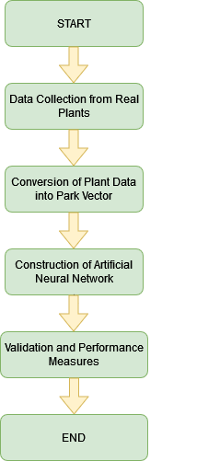

**Figure 1:** Development Flowchart

* 1. *Dataset Collection from Real Plants*

Raw data consisting of 3 phase stator current of the motor is being collected from three different real industrial plants. The raw dataset features include Motor ID, Electrical Team, 3 phase of currents, Vibration Team.

B. *Conversion of Plant Data into Park Vector’s*Conversion of Plant Data into Park Vector involves a series of following processes.

1. Plotting Actual Data of every motor.
2. Rescaling the plotted Currents against time.
3. Calculating the stator currents according to the formula in Eq 1 and 2, respectively and plot.
4. Envelope and plot stator IsD and IsQ component trajectory

|  |  |
| --- | --- |
| *IsD = √(2/3) Ia - (1/√6) Ib - –(1/√6) Ic* | (1) |

|  |  |
| --- | --- |
| *IsQ = (1/√2) Ib - –(1/√2) Ic* | (2) |

The Park vector Analysis gets its input from the 3 phases of the motor, and it plots it as a graph. The shape of the graph represents the health of the motor. A well-rounded circular graph represents a healthy motor, whereas an elliptical graph represents a motor that requires maintenance. The dataset comprises 36 images, whereas 28 park vectors are used for training, and eight are used for healthy and unhealthy testing***.*** The Heathy and unhealthy path vectors are depicted in Table 1 and Table 2, respectively.

**Table 1:** Example of Healthy Park Vectors in Training Dataset

|  |  |
| --- | --- |
| **HEALTHY** | |
| C:\Users\Abishek\UTP\Healthy\6 (3).png | C:\Users\Abishek\UTP\Healthy\6 (4).png |
| C:\Users\Abishek\UTP\Healthy\6 (5).png | C:\Users\Abishek\UTP\Healthy\6 (13).png |

**Table 2:** Example Training Dataset of UnHealthy Park Vectors

|  |  |
| --- | --- |
| **UNHEALTHY** | |
| C:\Users\Abishek\UTP\Unhealthy\6 (2).png | C:\Users\Abishek\UTP\Unhealthy\6 (6).png |
| C:\Users\Abishek\UTP\Unhealthy\6 (7).png | C:\Users\Abishek\UTP\Unhealthy\6 (8).png |

C. *Construction of ANN Model*

After collecting the dataset, the ANN architecture is constructed with layers of different inputs and activations functions which is explained in Figure 3. Then the trained data is fed into the ANN model. We achieve the training accuracy; we can end the training process and move the model to test it with testing data if the results are satisfying. Else it is required to fine-tune the model more to achieve the desired results. The whole flow of the network is being explained in Figure 2.

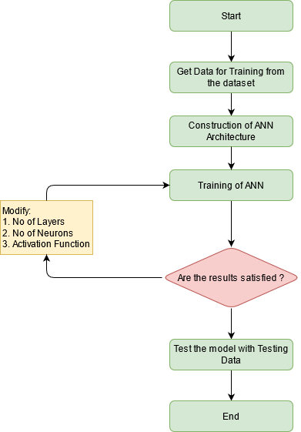

**Figure 2:** Network of ANN Model

C. *ANN Layers*

The classification is controlled by a simple Artificial Neural Network structure with three Dense Layers with 8, 4, and 1 unit. The first and second layer has an activation function of ReLU, and the final classification layer has an activation function of Sigmoid.

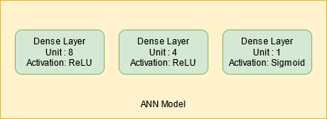

**Figure 3:** ANN Model

D. *Activation Functions*

Rectified linear unit (ReLU), sigmoid, tanh, exponential, softmax are some of the activation functions built into Keras. ReLU is generally preferred in the mid-layers of a neural network. The ReLU activation function returns 0 if the input is less than 0 and returns x if the input is greater than 0, visualized in Figure 4. The first and second Dense layers are controlled by the ReLu function.

|  |  |
| --- | --- |
| ReLU: f(x) = max(0,x) | (3) |

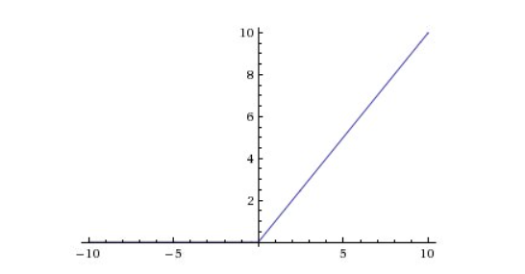

**Figure 4:** ReLU Function

Whereas the Sigmoid function activates the final layer. The sigmoid function is defined below in Eq. 4.

|  |  |
| --- | --- |
| $${σ\left(\vec{z}\right)}_{i}= \frac{1}{1+e^{-x}}$$ | (4) |

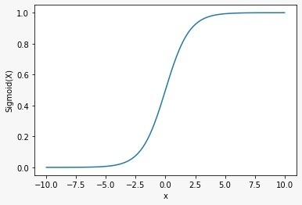

**Figure 5:** Sigmoid Function

E. *Loss Functions*

Categorical Cross Entropy is used as the loss function when the classification is one-hot encoded. The function is defined as-

|  |  |
| --- | --- |
| $$CCE\left(p,t\right)=-\sum_{n=1}^{n}{\left(t_{o,n} \log{{ p}_{o,n} }\right)}$$ | (5) |

where t is the target value and p is the predicted value.

# **Performance Measures**

Deciding on the cross-validation and performance measures to be used in analyzing a machine learning model is significant. Based on the performance of unseen data, we can say whether the model is overfitted, under fitted, or well generalized.

A confusion matrix is a tabular summary of the classifier's number of correct and incorrect predictions. It is used to judge the performance of the classification model. The terminologies used for classifications are True positive, True Negative, False Positivity, and False Negative. True Positives can be defined as the number of positive examples which are correctly classified as positive. True Negatives can be defined as the number of negative examples correctly classified as negative; False positives are the number of negative examples wrongly classified as positive. False Negatives are the number of positive examples wrongly classified as negative. The most importantly used performance matrices derived from the confusion matrix are accuracy, precision, recall, and F1 score.

Accuracy is the ratio of all the correctly classified samples to the total number of test samples shown in Eq. 6.

|  |  |
| --- | --- |
| $$Accuracy=\frac{TN+TP}{TN+TP+FN+FP}$$ | (6) |

where TN is true negative, TP is true positive, FN is false negative and FP is false positive.

Precision (also called positive predictive value) is the ratio of true positive to the total positive instances detected by the model as shown in Eq. 7. Recall is the ratio of true positive to the summation of true positive and false negative as shown in Eq. 8. F1 score and can be described as the harmonic mean of the precision and recall as shown in Eq. 9.

|  |  |  |
| --- | --- | --- |
| $$Precision= \frac{TP}{TP+FP}$$ |  | (7) |
| $$Recall=\frac{TP}{TP+FN}$$ |  | (8) |
| $$F1 score=2×\frac{Precision×Recall}{Precision+Recall}$$ |  | (9) |
| **Table 5.** Testing Predictions |  |  |

1. **Results and Discussions**

From the confusion matrix in Table 4, it is detected that the FN, FP and TN rates are null for all the classes stating the Accuracy, Precision, Recall and F1 Score to be greater than 99% as given in Table 3.

**Table 3.** Testing Result Analysis of Proposed Method in terms of distinct measures

|  |  |  |  |
| --- | --- | --- | --- |
| **F1 Score** | **Accuracy** | **Precision** | **Recall** |
| 100 | 100 | 100 | 100 |

**Table 4.** Results in Confusion Matrix for Test Dataset

|  |  |  |
| --- | --- | --- |
|  | Healthy | UnHealthy |
| Healthy | 16 | 0 |
| UnHealthy | 0 | 20 |

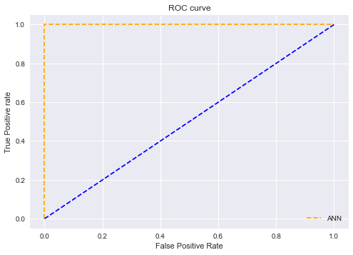

**Figure 6.** ROC Curve

Testing Predictions derived from the confusion matrix are shown visually are shown in Table 5 with specific True Values and Prediction Columns.

|  |  |  |
| --- | --- | --- |
| **Park Vector** | **True Values** | **Prediction** |
| C:\Users\Abishek\Downloads\download (10).png | Healthy | Healthy |
| C:\Users\Abishek\Downloads\download (12).png | Healthy | Healthy |
| C:\Users\Abishek\Downloads\download (11).png | Healthy | Healthy |
| C:\Users\Abishek\Downloads\download (13).png | UnHealthy | UnHealthy |
| C:\Users\Abishek\Downloads\download (16).png | UnHealthy | UnHealthy |

# **conclusion**

In the proposed work, ANN model for the various bearing fault segregation classification has been developed based on Park’s vector analysis of three-phase stator currents. The experimental results indicate that the developed ANN model renders >99% classification results for the dataset. It can be foreseen that the proposed method will enhance the reliability and accuracy of the methods used for the online detection and diagnosis of various bearing faults. Further, the proposed and designed model is compatible with Linux OS and can thus be deployed in a RaspberryPi (RPI), the preferred edge device in most industries for industrial automation. The deployed model has proved to be robust and stable and has outperformed the accuracy of the existing predictive maintenance models. The usage of RPI enables the industry to conduct predictive maintenance at a low-cost factor and a minuscule energy footprint, thus enabling enterprises to reduce full-scale maintenance and run the plants smoothly and effectively.

# **REFERENCES**

[1] R. N. Toma, A. E. Prosvirin, and J.-M. Kim, “Bearing fault diagnosis of induction motors using a genetic algorithm and machine learning classifiers,” *Sensors,* vol. 20, no. 7, pp. 1884, 2020.

[2] M. Valtierra-Rodriguez, J. R. Rivera-Guillen, J. A. Basurto-Hurtado, J. J. De-Santiago-Perez, D. Granados-Lieberman, and J. P. Amezquita-Sanchez, “Convolutional neural network and motor current signature analysis during the transient state for detection of broken rotor bars in induction motors,” *Sensors,* vol. 20, no. 13, pp. 3721, 2020.

[3] X. Song, J. Hu, H. Zhu, and J. Zhang, “A bearing outer raceway fault detection method in induction motors based on instantaneous frequency of the stator current,” *IEEJ Transactions on Electrical and Electronic Engineering,* vol. 13, no. 3, pp. 510-516, 2018.

[4] K. D. Kompella, M. V. G. Rao, and R. S. Rao, “Bearing fault detection in a 3 phase induction motor using stator current frequency spectral subtraction with various wavelet decomposition techniques,” *Ain Shams Engineering Journal,* vol. 9, no. 4, pp. 2427-2439, 2018.

[5] L. Collamati, F. Filippetti, G. Franceschini, S. Pirani, and C. Tassoni, "Induction machine stator fault on-line diagnosis based on LabVIEW environment." pp. 495-498.

[6] S. Singh, A. Kumar, and N. Kumar, “Motor current signature analysis for bearing fault detection in mechanical systems,” *Procedia Materials Science,* vol. 6, pp. 171-177, 2014.

[7] D. Miljković, “Brief review of motor current signature analysis,” *HDKBR Info magazin,* vol. 5, no. 1, pp. 14-26, 2015.

[8] S. Vigneshkumar, V. K. Shankar, P. N. Krishna, and P. Supriya, "Fault detection in gearbox using motor electrical signature analysis." pp. 1-6.

[9] Q. S. Al-Sabbagh, and H. E. Alwan, “Detection of static air-gap eccentricity in three phase induction motor by using artificial neural network (ANN),” *Journal of Engineering,* vol. 15, no. 4, 2009.

[10] V. Ghate, and S. Dudul, “Artificial neural network based fault classifier for three phase induction motor,” *International Journal of Computational Intelligence Research,* vol. 5, no. 1, pp. 25-37, 2009.

[11] M. Khazaee, H. Ahmadi, M. Omid, A. Banakar, and A. Moosavian, “Feature-level fusion based on wavelet transform and artificial neural network for fault diagnosis of planetary gearbox using acoustic and vibration signals,” *Insight-Non-Destructive Testing and Condition Monitoring,* vol. 55, no. 6, pp. 323-330, 2013.

[12] W. Dai, H. Nishi, V. Vyatkin, V. Huang, Y. Shi, and X. Guan, “Industrial edge computing: Enabling embedded intelligence,” *IEEE Industrial Electronics Magazine,* vol. 13, no. 4, pp. 48-56, 2019.

[13] S. Shashidhara, and P. S. Raju, “BEARING FAULT DETECTION OF INDUCTION MOTOR BY ANN METHOD,” 2014.

[14] M. Irfan, N. Saad, R. Ibrahim, V. S. Asirvadam, and A. Alwadie, “Analysis of distributed faults in inner and outer race of bearing via Park vector analysis method,” *Neural Computing and Applications,* vol. 31, no. 1, pp. 683-691, 2019.

[15] M. Irfan, N. Saad, R. Ibrahim, V. S. Asirvadam, A. S. Alwadie, and M. A. Sheikh, “An assessment on the non-invasive methods for condition monitoring of induction motors,” *Fault Diagnosis and Detection*, pp. 87, 2017.

[16] N. Mehala, and R. Dahiya, “Detection of bearing faults of induction motor using Park’s vector approach,” *International Journal of Engineering and Technology,* vol. 2, no. 4, pp. 263-266, 2010.

[17] J. Zarei, and S. Yousefizadeh, *Fault Detection in Induction Motors using Park's Vector Approach and Wavelet Analysis*, 2014.

[18] A. Sharma, S. Chatterji, and L. Mathew, "A novel Park’s vector approach for investigation of incipient stator fault using MCSA in three-phase induction motors." pp. 1-5.

[19] T. G. Vilhekar, M. S. Ballal, and H. M. Suryawanshi, “Application of Multiple Parks Vector Approach for Detection of Multiple Faults in Induction Motors,” *Journal of Power Electronics,* vol. 17, no. 4, pp. 972-982, 2017.

[20] J. Burriel-Valencia, A. Sapena-Baño, M. Pineda-Sanchez, and J. Martinez-Roman, "Multilayer Park's vector approach, a method for fault detection on induction motors." pp. 775-780.

[21] P. K. Kankar, S. C. Sharma, and S. P. Harsha, “Fault diagnosis of ball bearings using machine learning methods,” *Expert Systems with applications,* vol. 38, no. 3, pp. 1876-1886, 2011.

[22] S. M. Jawad, and A. A. Jaber, "A Data-Driven Approach Based Bearing Faults Detection and Diagnosis: A Review." p. 012111.

[23] T. A. Dhomad, and A. A. Jaber, “Bearing fault diagnosis using motor current signature analysis and the artificial neural network,” *International Journal on advanced scince Engineering Information Technology,* vol. 10, 2020.

[24] Wen, Long; Li, Xinyu; Gao, Liang (2019). A transfer convolutional neural network for fault diagnosis based on ResNet-50. Neural Computing and Applications, (), –. doi:10.1007/s00521-019-04097-w